操作系统作业4

1. Consider the deadlock situation that can occur in the diningphilosophers problem when the philosophers obtain the chopsticks one at a time. Discuss how the four necessary conditions for deadlock hold in this setting. Describe a deadlock-free solution, and discuss which necessary conditions are eliminated in your solution.
2. Consider the exponential average formula used to predict the length of the next CPU burst. What are the implications of assigning the following values to the parameters used by the algorithm?

a. $α$ = 0 and $τ_{0}$ = 100 milliseconds

b. $α$ = 0.99 and $τ_{0}$ = 10 milliseconds

1. Consider the following set of processes, with the length of the CPU burst time given in milliseconds:

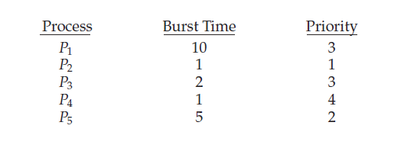

The processes are assumed to have arrived in the order P1, P2, P3, P4, P5, all at time 0.

* 1. Draw four Gantt charts that illustrate the execution of these processes using the following scheduling algorithms: FCFS, SJF (nonpreemptive), nonpreemptive priority (a smaller priority number implies a higher priority), and RR (quantum = 1).
  2. What is the turnaround time of each process for each of the scheduling algorithms in part a?
  3. What is the waiting time of each process for each of these scheduling algorithms?
  4. Which of the algorithms results in the minimum average waiting time (over all processes)?

1. Which of the following scheduling algorithms could result in starvation?
   1. First-come, first-served
   2. Shortest job first
   3. Round robin
   4. Priority
2. Consider a system running ten I/O-bound tasks and one CPU-bound task. Assume that the I/O-bound tasks issue an I/O operation once for every millisecond of CPU computing and that each I/O operation takes 10 milliseconds to complete. Also assume that the context-switching overhead is 0.1millisecond and that all processes are long-running tasks. Describe is the CPU utilization for a round-robin scheduler when:
   1. The time quantum is 1 millisecond
   2. The time quantum is 10 milliseconds
3. Give an example to illustrate under what circumstances rate-monotonic scheduling is inferior to earliest-deadline-first scheduling in meeting the deadlines associated with processes?